# Chapter 3 Thermal Comfort

## Thermal Comfort

Thermal comfort is the condition of mind that expresses satisfaction with the thermal environment

and is assessed by subjective evaluation such as ANSI/ASHRAE Standard 55.

## **ANSI/ASHRAE Standard 55**

According to the definition from Wikipedia, thermal Environmental Conditions for Human Occupancy is a standard that provides minimum requirements for acceptable thermal indoor environments.

The purpose of the Thermal standard is to specify the combinations of indoor thermal environmental factors and personal factors that will produce thermal environmental conditions acceptable to a majority of the occupants within the space. The standard addresses the four primary environmental factors (temperature, thermal radiation, humidity, and air speed) and two personal factors (activity and clothing) that affect thermal comfort. It is applicable for healthy adults at atmospheric pressures in altitudes up to (or equivalent to) 3000 m (9800 feet), and for indoor spaces designed for occupancy of at least 15 minutes.

## CBE Thermal Comfort Tool for ASHRAE-55

Here we introduce the third-party tool from Berkeley to evaluate the comfort based on the two types of input data in our data set: indoor temperature and outdoor temperature retrieved through API interface provided from worldweatheronline.com. The reason we have mentioned the in previous chapter about the unreliable of the outdoor temperature measurement from weather station and we want to remove the unstable affection out of this evaluation.

### **Comfort for all sites**

In this section, we will discuss about the overall comfort for all sites.

We use CBE tools and binary classifier algorithm to calculate output result as two different situations: comfort =1 and un-comfort =0.

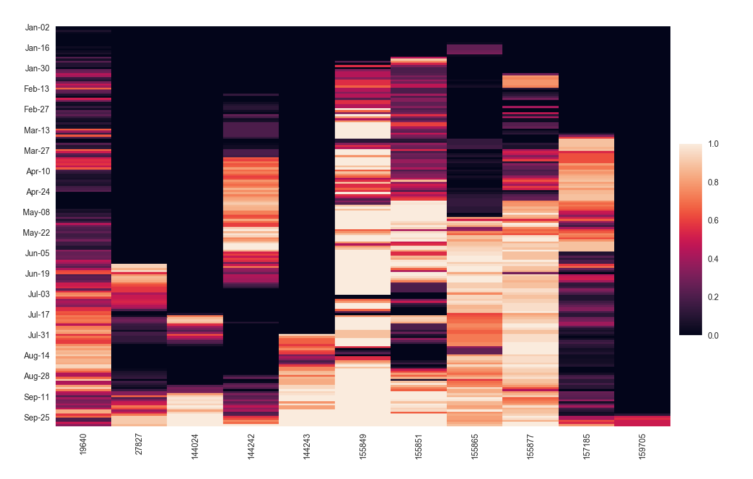

Fig. X Comfort all the sites participating in the GAIA platform is provided for a period of ten months from January/01/2017 to September/30/2017.

In the Fig. X each column represents one single site with average output of all rooms comfort. And each row represents one single day limited in workdays between Monday to Friday at 08:00 to 16:00(time interval: hourly) the average of the comfort situation for each site. Due to the inactivity of the sites which has no indoor temperature data cause the long-term uncomfortable situation like school 159705 from January to middle September.

From the fig. X, site 155849 stands out with very stable comfort condition for all the rooms while the site 157185 are keep moving up and down but never achieve the comfortable status in the entire school but some rooms occasionally from late August to the end of September.

For schools during the active period: School 155877 and 155849 indicate better comfort compared with other school, meanwhile School 19640 is continuously switching between comfort and un-comfort

The location for school 155877 is on the south of Greece while school 19640 is on the north. The geography location could be one of the reasons. And school 155849 is close to the capital which has good financial support to provide considerably better comfortable environment such as using the heating, ventilation, and air conditioning system.

Apart from the reasons are mentioned above, there are other reasons that affect thermal comfort, e.g., such as the construction materials, the location and surround environment of the school and orientation and location of the classroom which affect the day time exposed in the sunlight and also the position of the air conditioner system inside the classrooms.

Part of those data are not included in the GAIA platform which is hard to determine which is the key effect on the comfort.

### **Comfort for single site**

The figures in this section indicate one single site, different rooms’ comfort classifier result 1 or 0 corresponding to each hour during the working day and working time, instead of the average of the all the rooms’ results. In the same school, at the same time these results still have different behaviour considering the same outdoor temperature. We introduce the other features, such as the orientation of sensor device locations, the location or the usage for the classroom to seek the possible pattern.

We cross checked the comfort with information from Chapter 2 floor plan and the Table X below.

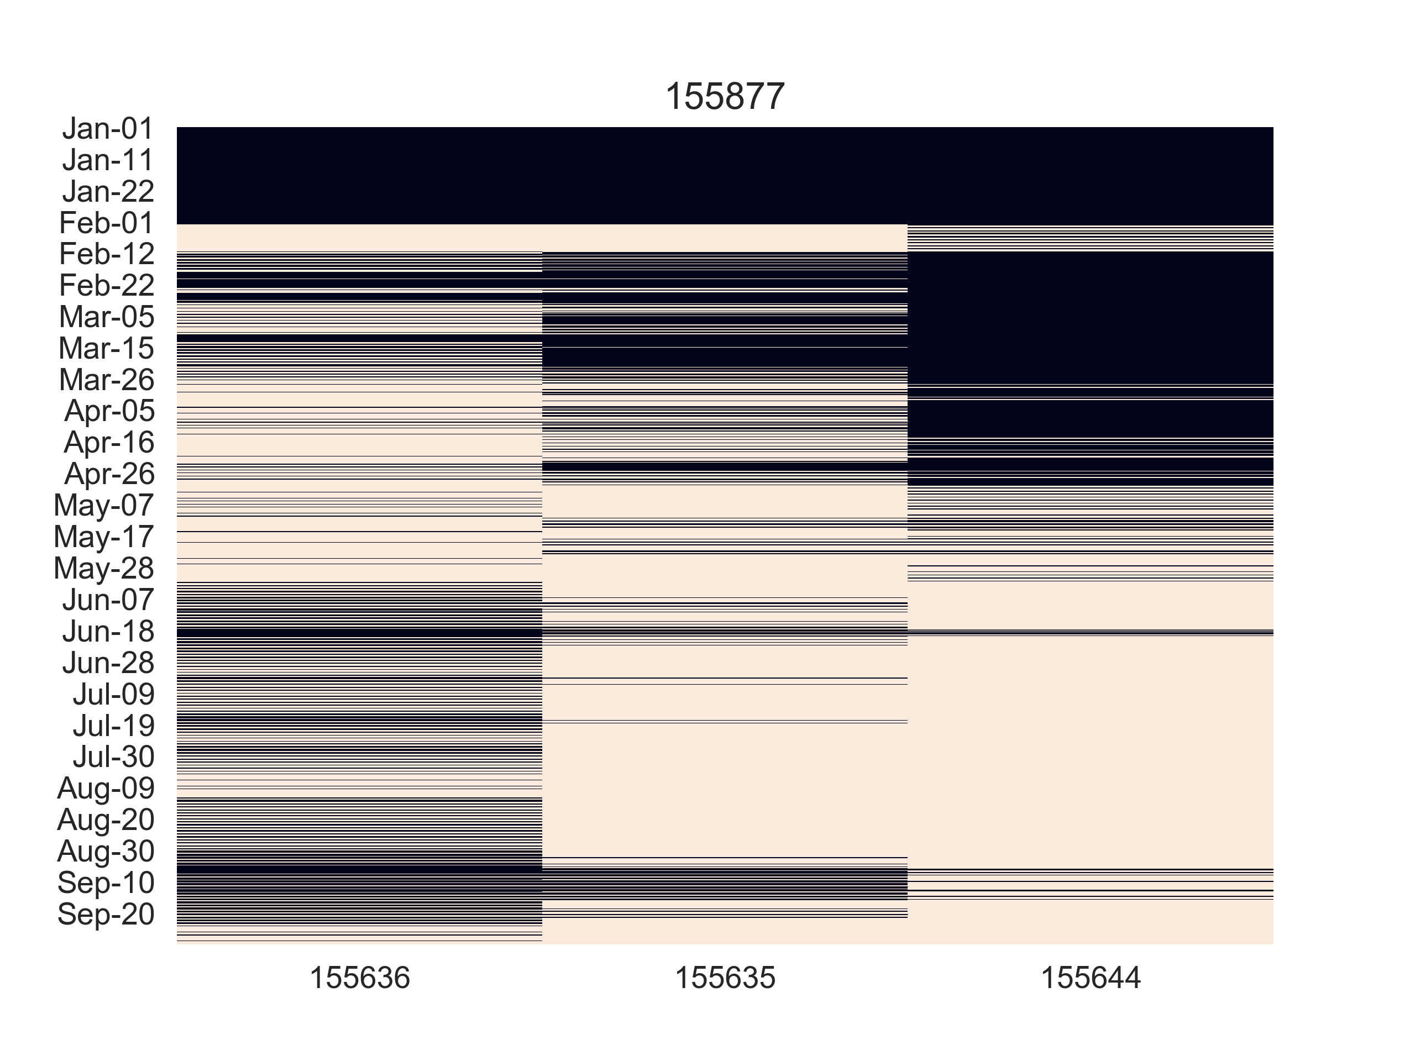

For the class11(155636 facing to the north-west) on the floor plan it appears better comfort in and spring seasons but the class7(155644 facing to the south-east) has better condition in summer and early autumn season. And the class 8(155635 facing to the south) are switch between good and back for all the winter spring time only have less fluctuate in the summer season. And this pattern fit the seasoning pattern on exposure time and angle from sunlight.

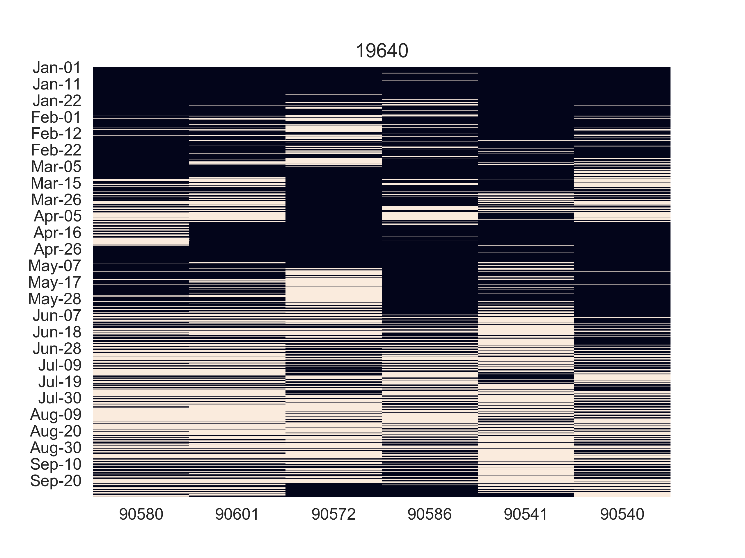

When we look at the worse performance example school 19640, it presents interesting variability no longer based on the orientation but on the location, usage. The first two classes class 1(90580) and class 2(90601) are sharing similarity not only their locations also their comfort. And the music class and laboratory are also sharing the similarity on comfort while by their usage for dedicated purpose.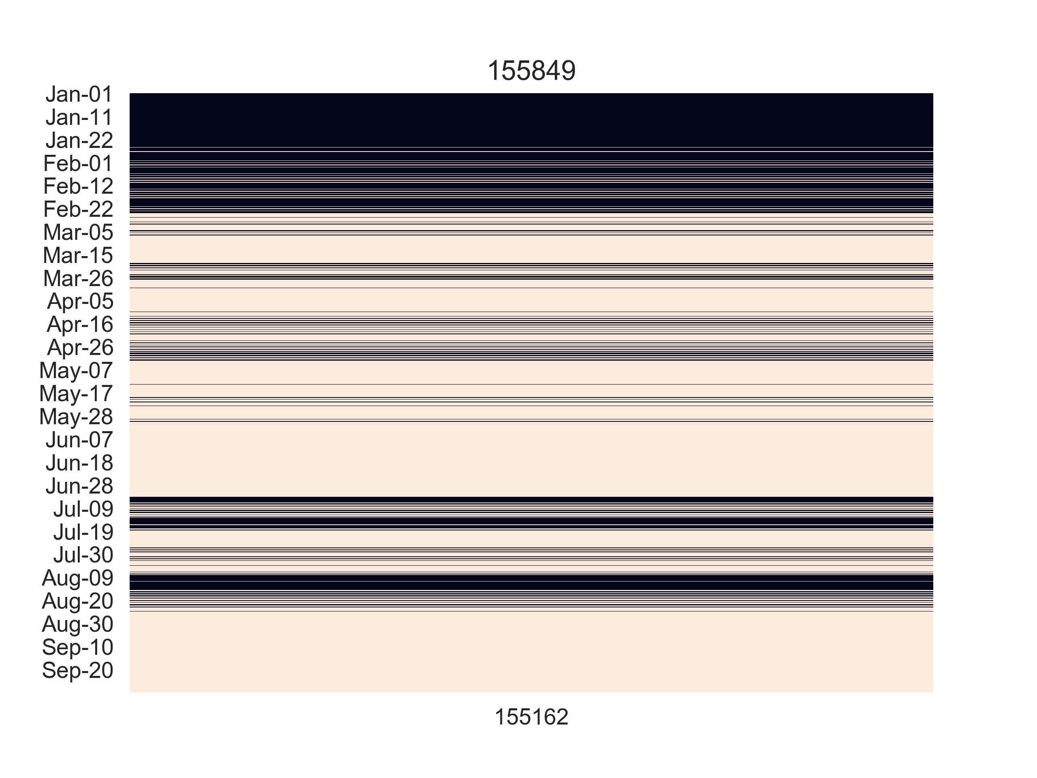

For this school 155849, there is only one class 0x312 (155162 facing to the north-west) being counted into the comfort performance and also another reason why this school could stand out among so many schools in the first section. In this Fig. X it shows clear pattern that: from March to September most of the time this room mains in the comfort condition. Its most uncomfortable time are in summer and winter season.

As the rest of the result we list here but not going to discuss each of them.

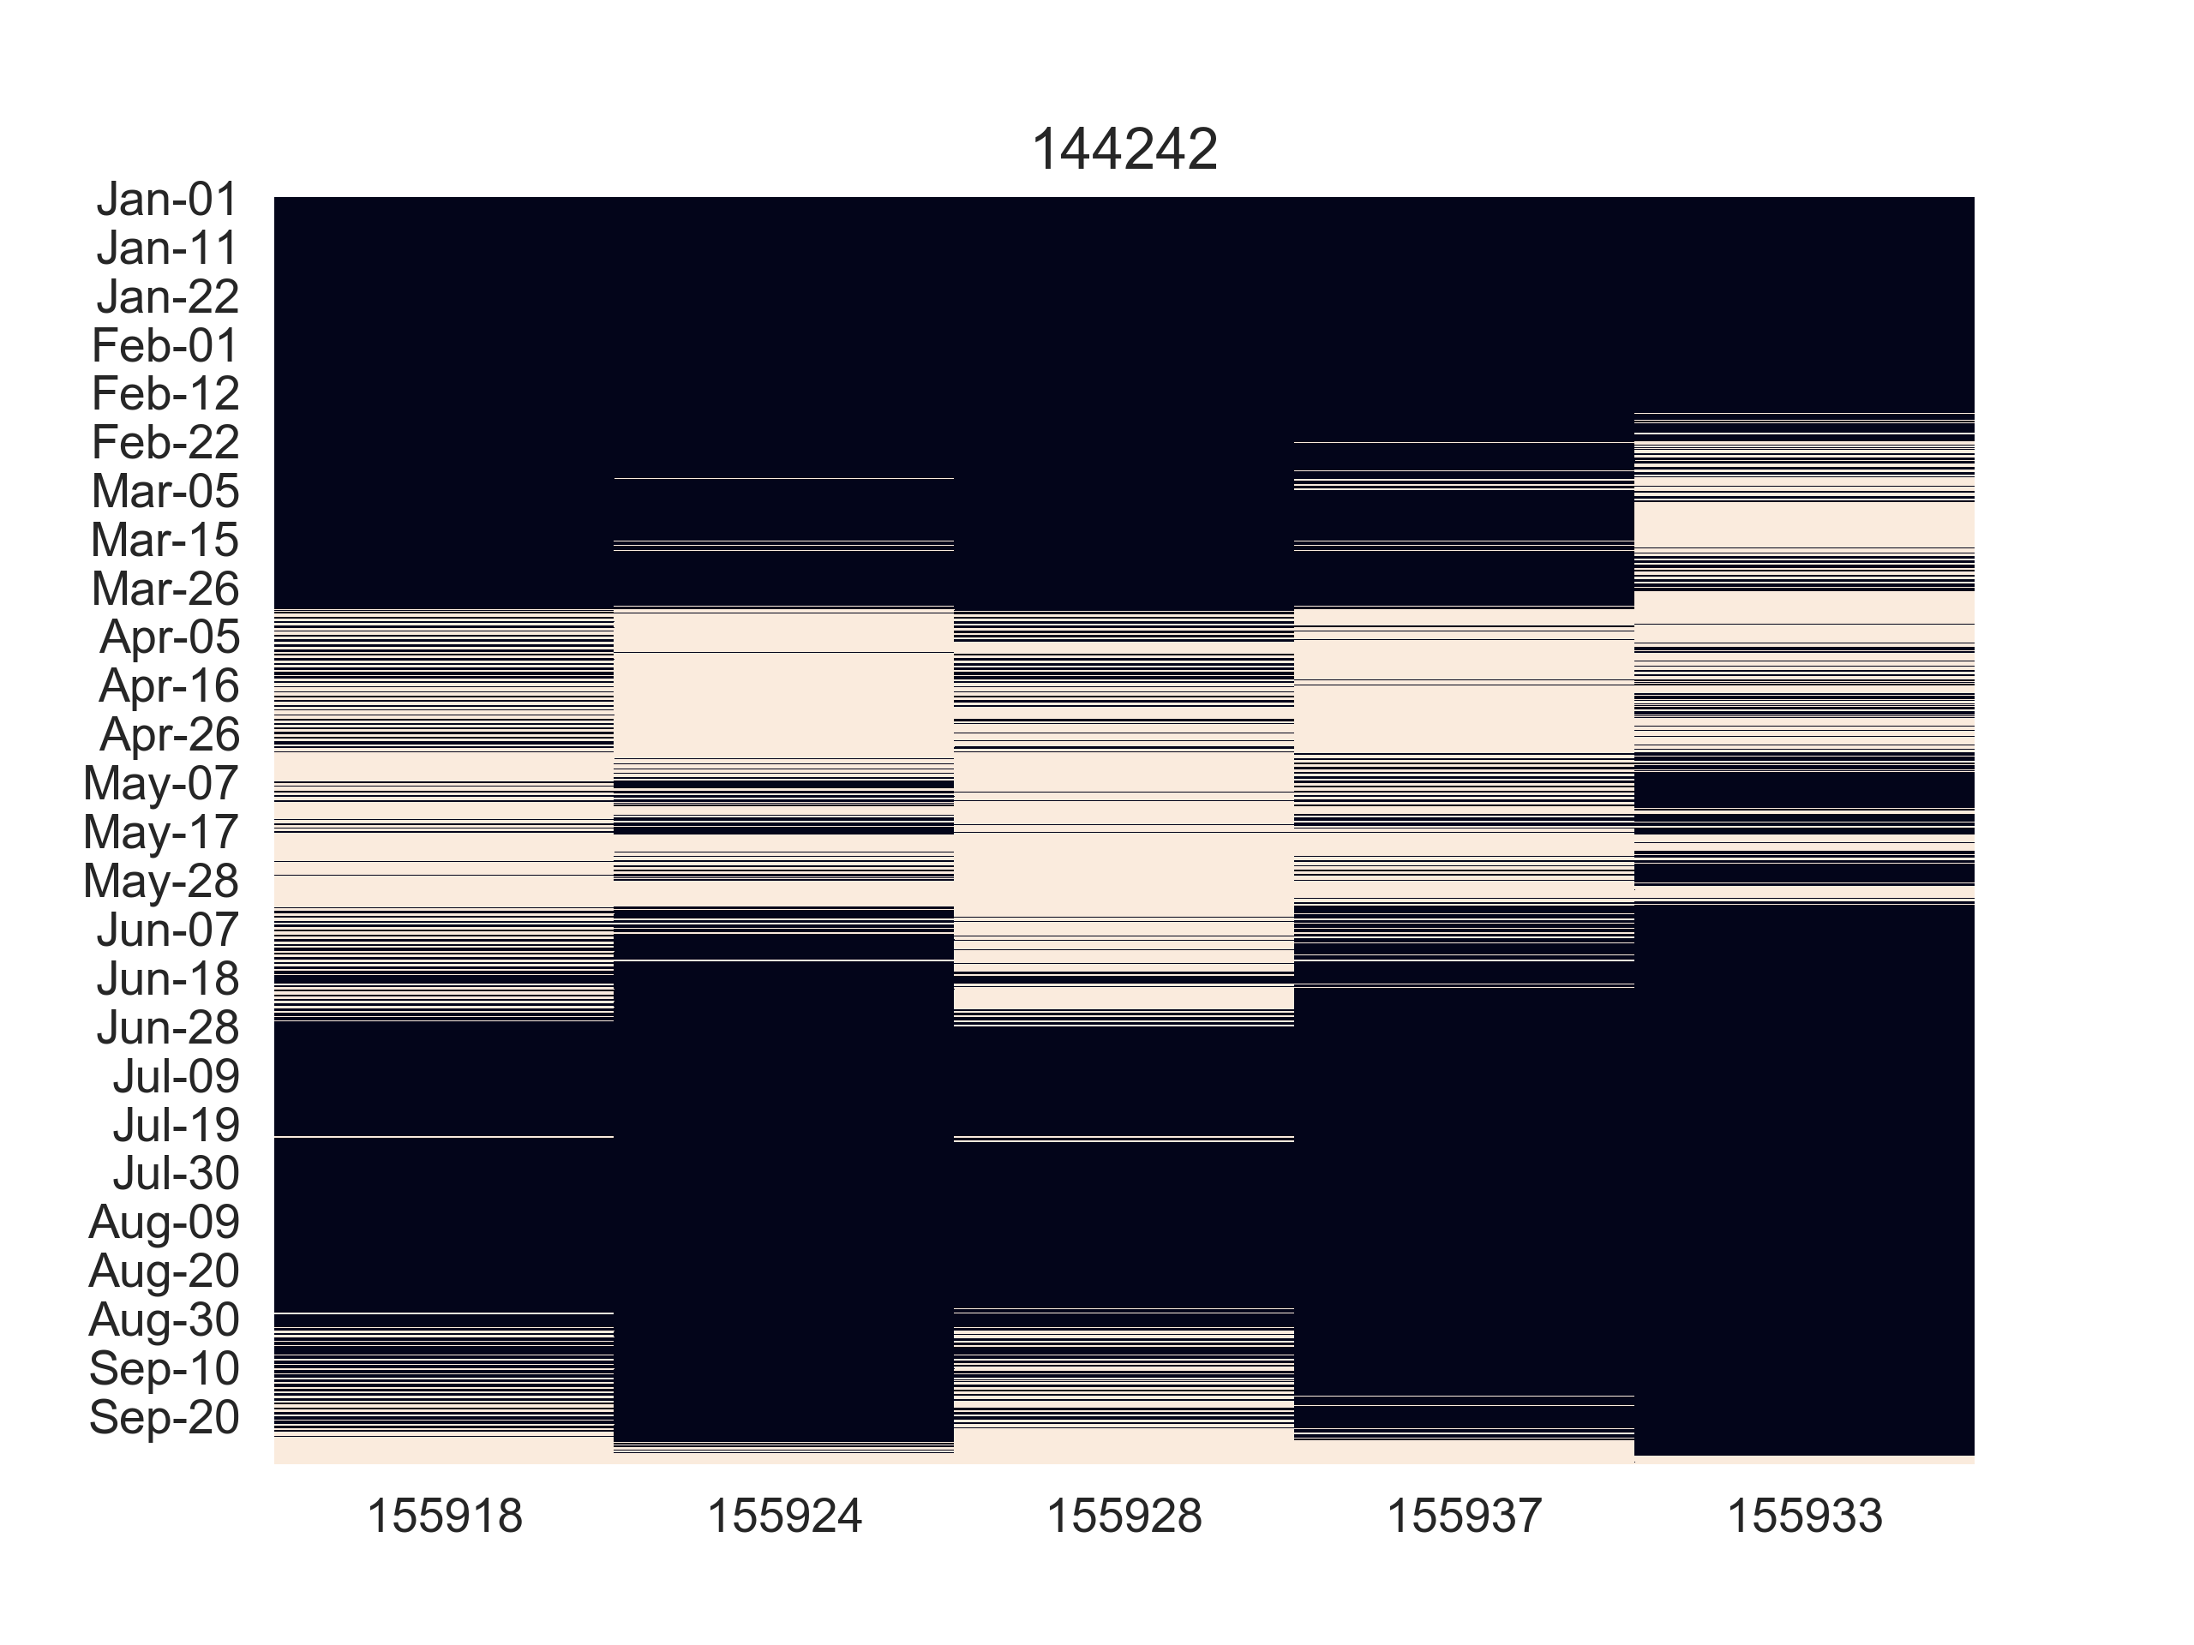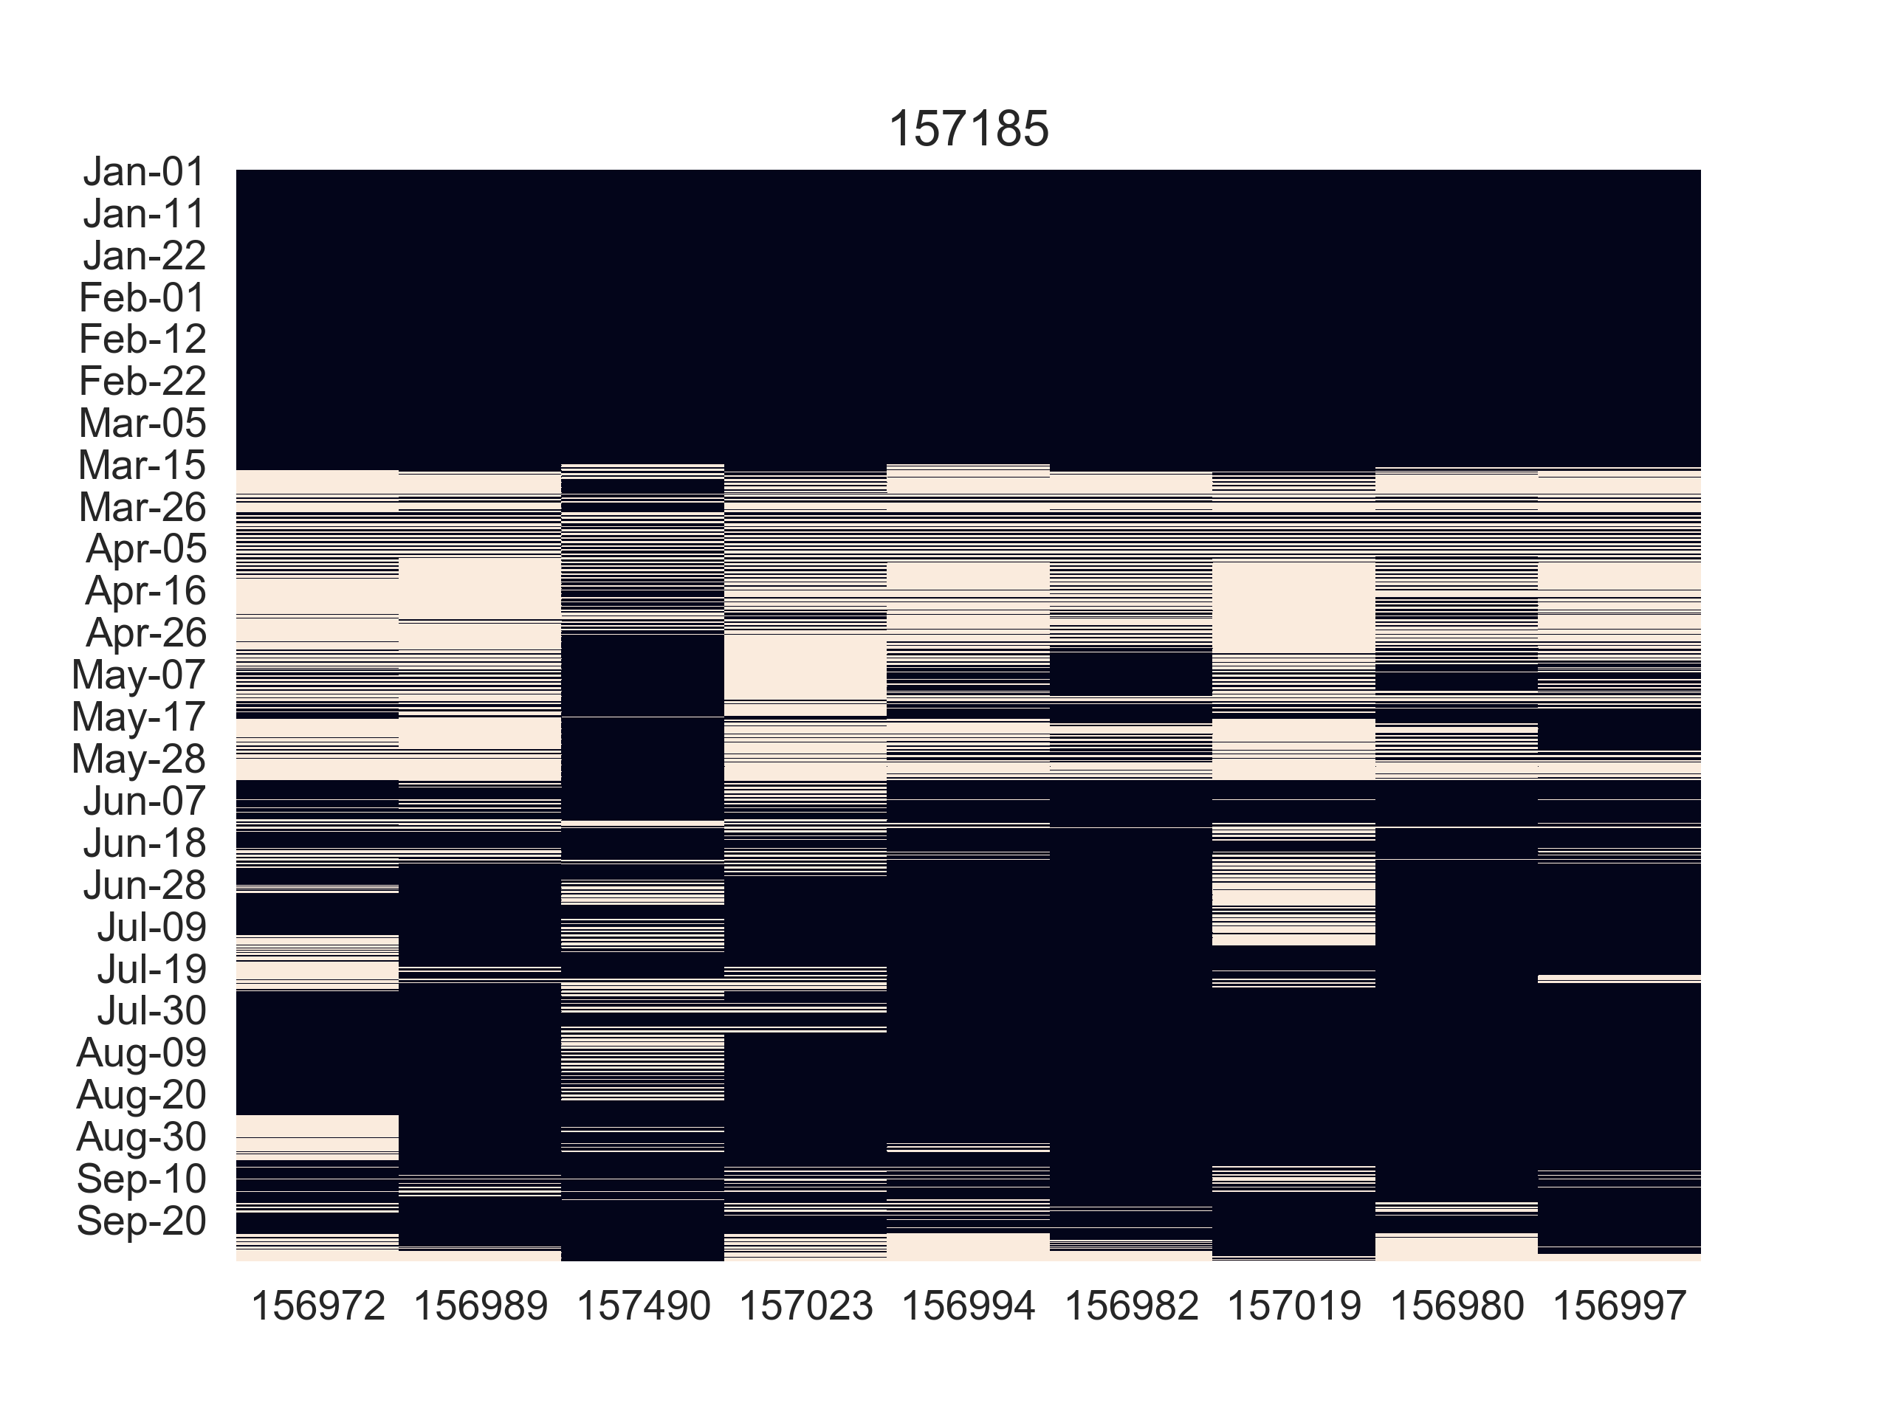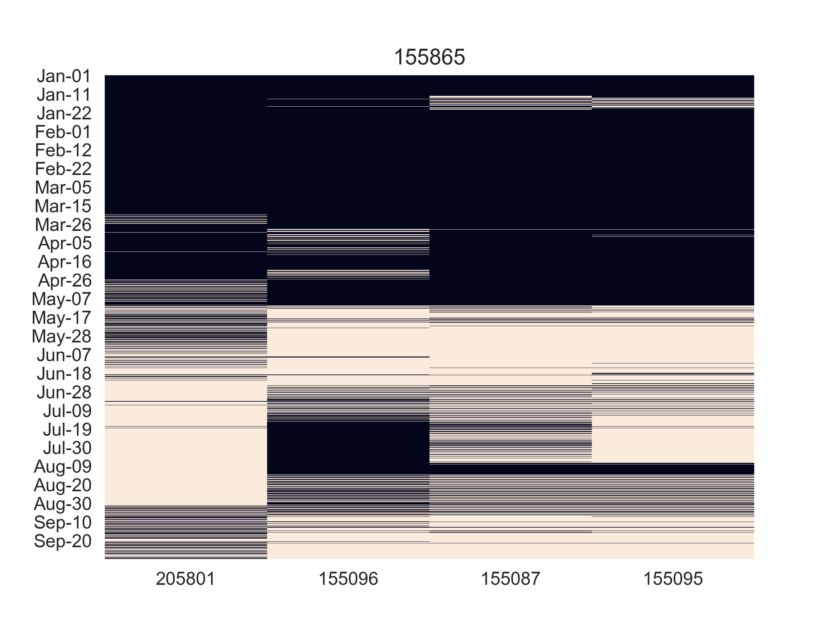

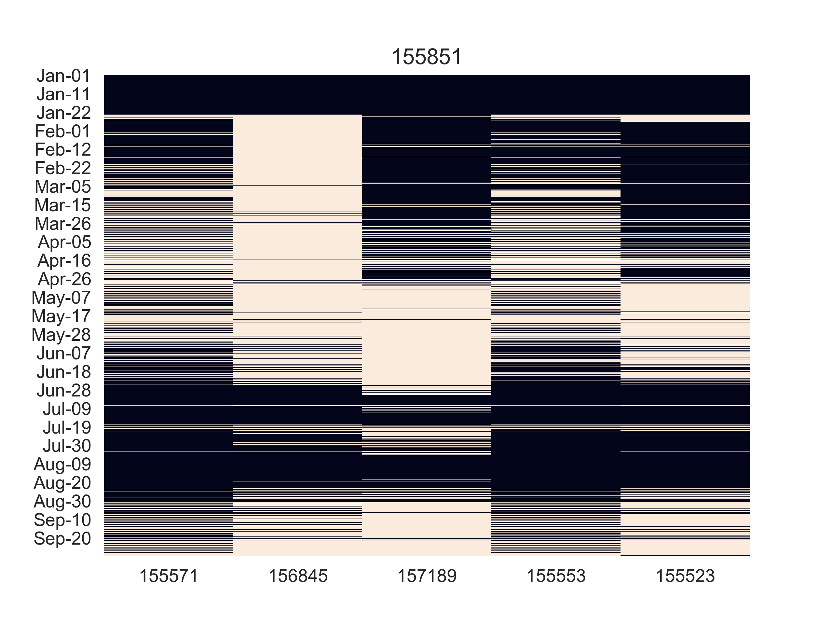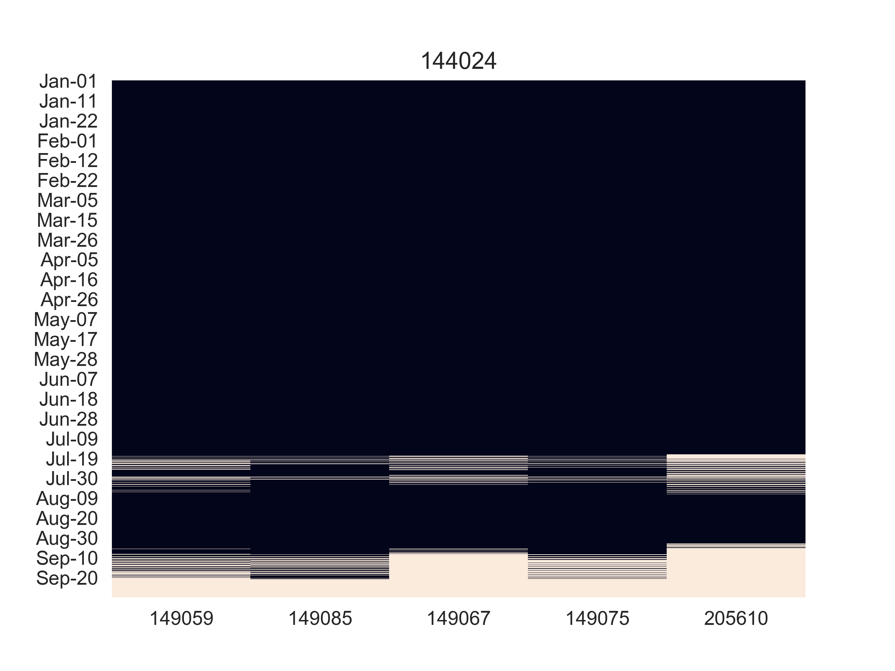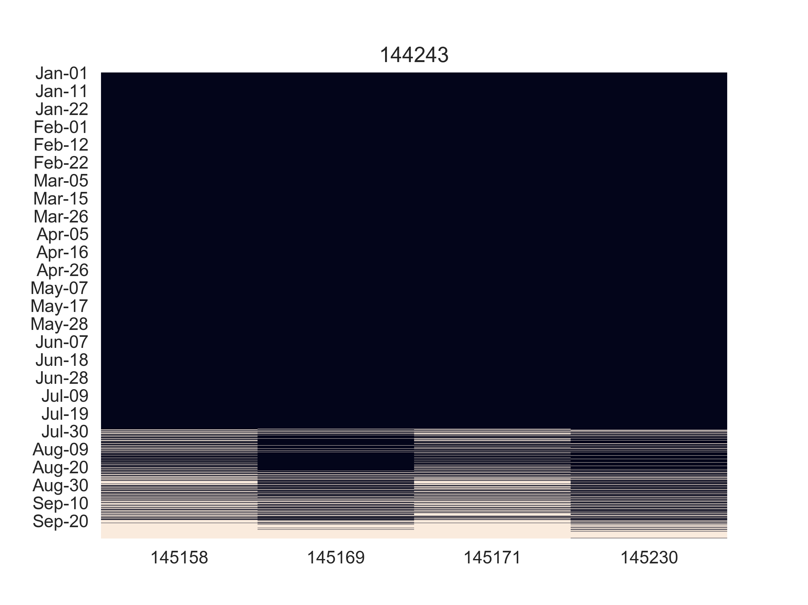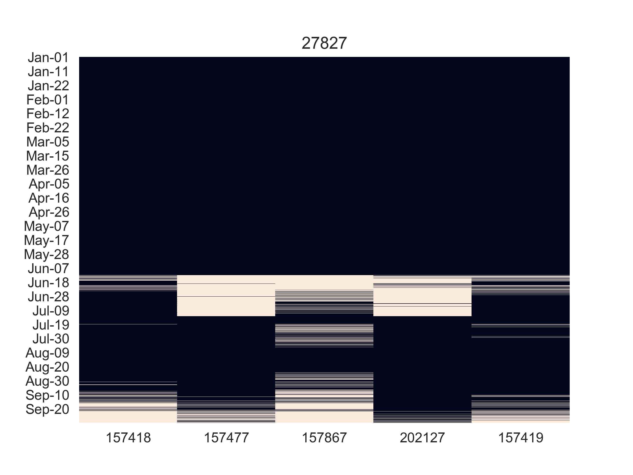

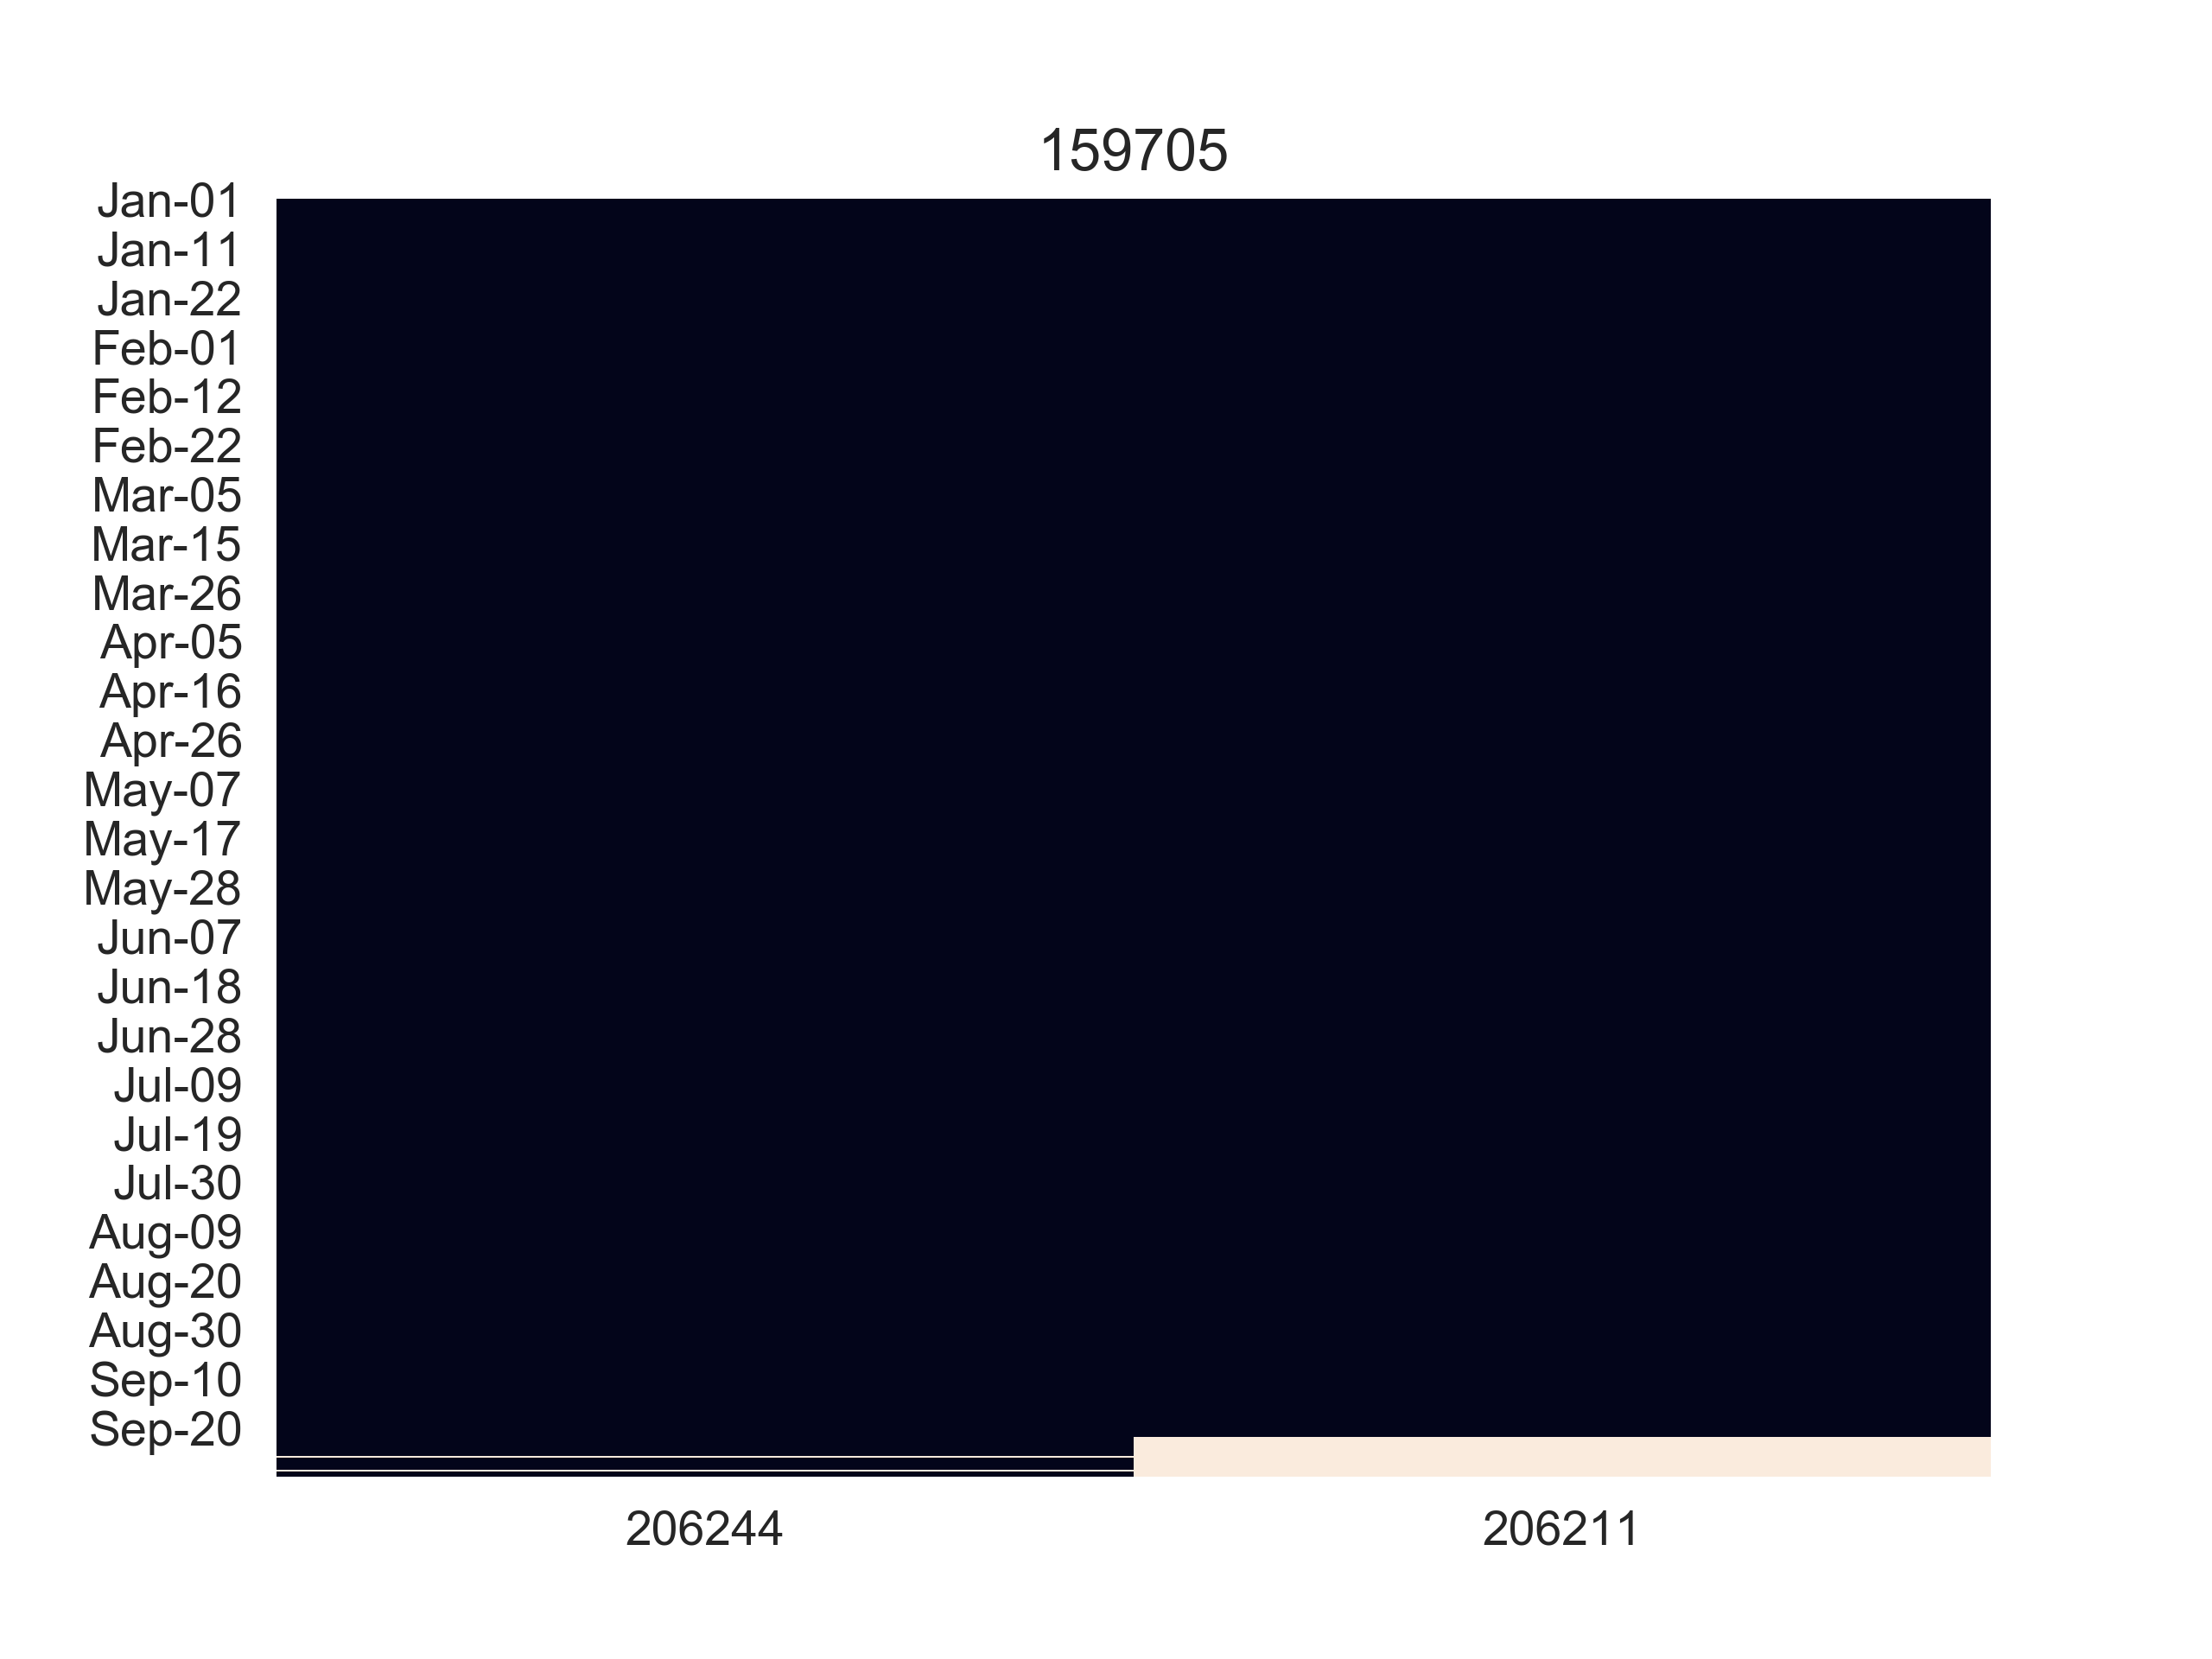

|  |  |  |  |
| --- | --- | --- | --- |
| Site ID | Room sensor ID | Room Orientation | Room alias on floor plan |
| 144024 | 149059 | South-East | 0xfe6 |
| 144024 | 149085 | South-East | 0xd1e |
| 144024 | 149067 | South-East | 0xd21 |
| 144024 | 149075 | South-East | 0xd1d |
| 144024 | 205610 | South-East | 0xff3 |
| 144243 | 145158 | South-West | 0xfe8 |
| 144243 | 145169 | North-West | 0x192 |
| 144243 | 145171 | South-West | 0xd28 |
| 144243 | 145230 | West | 0xd25 |
| 155851 | 155571 | South-East | 0xd26 |
| 155851 | 156845 | South-West | 0xd09 |
| 155851 | 157189 | North-West | 0x376 |
| 155851 | 155553 | South-East | 0x331 |
| 155851 | 155523 | South-East | 0x950 |
| 155865 | 205801 | South-West | 0x3bd |
| 155865 | 155096 | South-West | 0xd19 |
| 155865 | 155087 | North-East | 0xd1a |
| 155865 | 155095 | North-East | 0xfef |
| 19640 | 90580 | North-East | 0xecb |
| 19640 | 90601 | North-East | 0x4fd |
| 19640 | 90572 | North-East | 0xae1 |
| 19640 | 90586 | North-East | 0xa2c |
| 19640 | 90541 | South-East | 0x83d |
| 19640 | 90540 | South-West | 0xf15 |
| 27827 | 157418 | North-West | 0xe28 |
| 27827 | 157477 | North-West | 0x317 |
| 27827 | 157867 | North-West | 0x4ce |
| 27827 | 202127 | South-East | 0x2ff |
| 27827 | 157419 | South-West | 0xfb8 |
| 144242 | 155918 | South-East | 0xd1b |
| 144242 | 155924 | North-West | 0x383 |
| 144242 | 155928 | South-East | 0xd15 |
| 144242 | 155937 | North-West | 0xd18 |
| 144242 | 155933 | North-West | 0xd16 |
| 155877 | 155636 | South-West | 0x68a |
| 155877 | 155635 | South-West | 0x6a0 |
| 155877 | 155644 | South-East | 0x672 |
| 159705 | 206446 | South-East | pi3 |
| 159705 | 206244 | North-East | pi2 |
| 159705 | 206211 | North-West | pi1 |
| 159705 | 206470 | South-East | Pi7 |
| 159705 | 206459 | North-East | Pi6 |
| 159705 | 206465 | South-West | Pi5 |
| 159705 | 206455 | South-West | pi4 |
| 155849 | 155162 | North-West | 0x312 |
| 157185 | 156972 | South-East | room-1 |
| 157185 | 156989 | North-East | room-4 |
| 157185 | 157490 | South-East | flareEA-1 |
| 157185 | 157023 | South-West | room-8 |
| 157185 | 156994 | North-East | room-5 |
| 157185 | 156982 | South-West | room-3 |
| 157185 | 157019 | North-East | room-7 |
| 157185 | 156980 | South-West | room-2 |
| 157185 | 156997 | North-East | room-6 |